Test Case: tc001_SPX_Dev5_Crear_Requisicion_Spot_Tipo_Cobro_CC
Step 1 - Enter username and password and click to button Enter : Credentials Entered
Image file-name: QC_Testing-tc001_SPX_Dev5_Crear_Requisicion_Spot_Tipo_Cobro_CC-1788297161130

Step 2 - Select to UEN and Access to Spot Buy Requisitions : UEN Correctly selected and Correct access
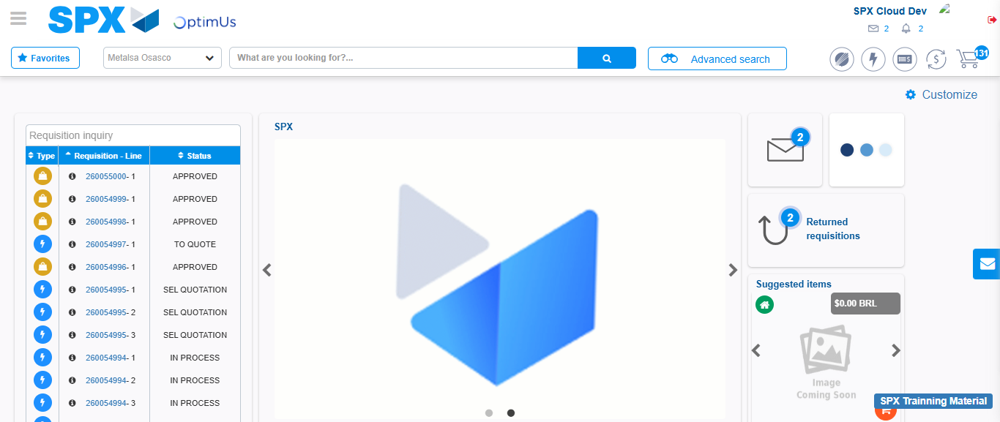Image file-name: QC_Testing-tc001_SPX_Dev5_Crear_Requisicion_Spot_Tipo_Cobro_CC-1788297186868

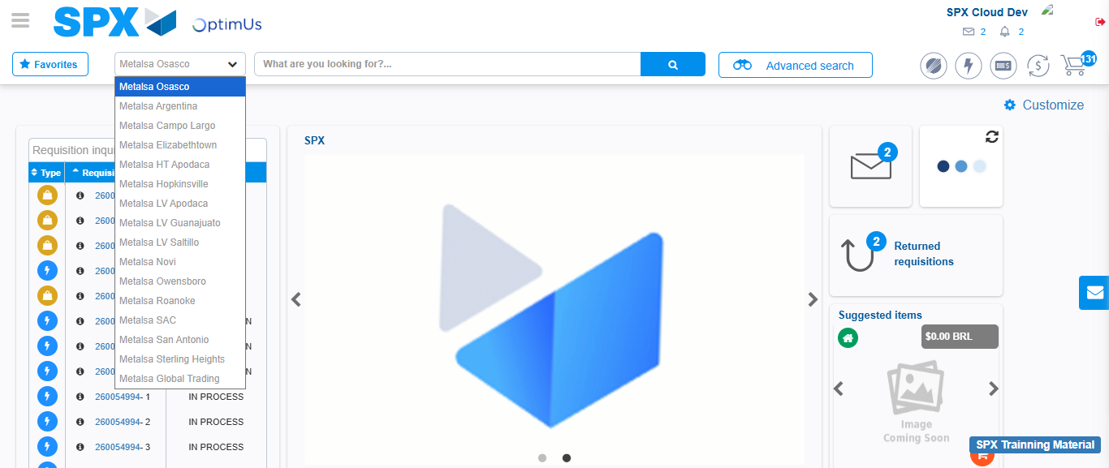Image file-name: QC_Testing-tc001_SPX_Dev5_Crear_Requisicion_Spot_Tipo_Cobro_CC-1788297187434

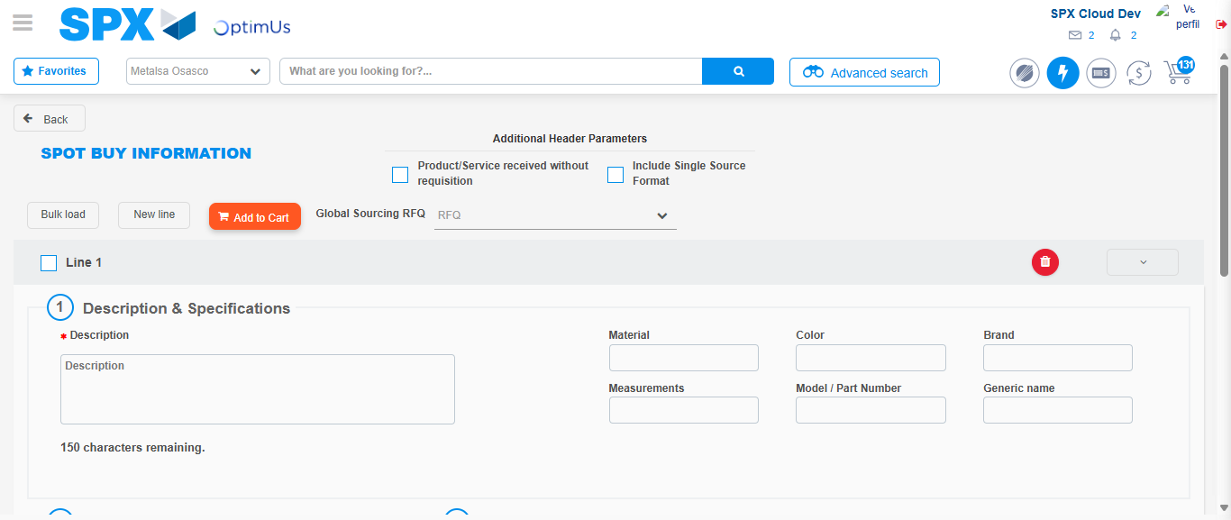Image file-name: QC_Testing-tc001_SPX_Dev5_Crear_Requisicion_Spot_Tipo_Cobro_CC-1788297210666

Step 3 - Data Capture Spot Buy Requisition : Data captured correctly
Image file-name: QC_Testing-tc001_SPX_Dev5_Crear_Requisicion_Spot_Tipo_Cobro_CC-1788297210904

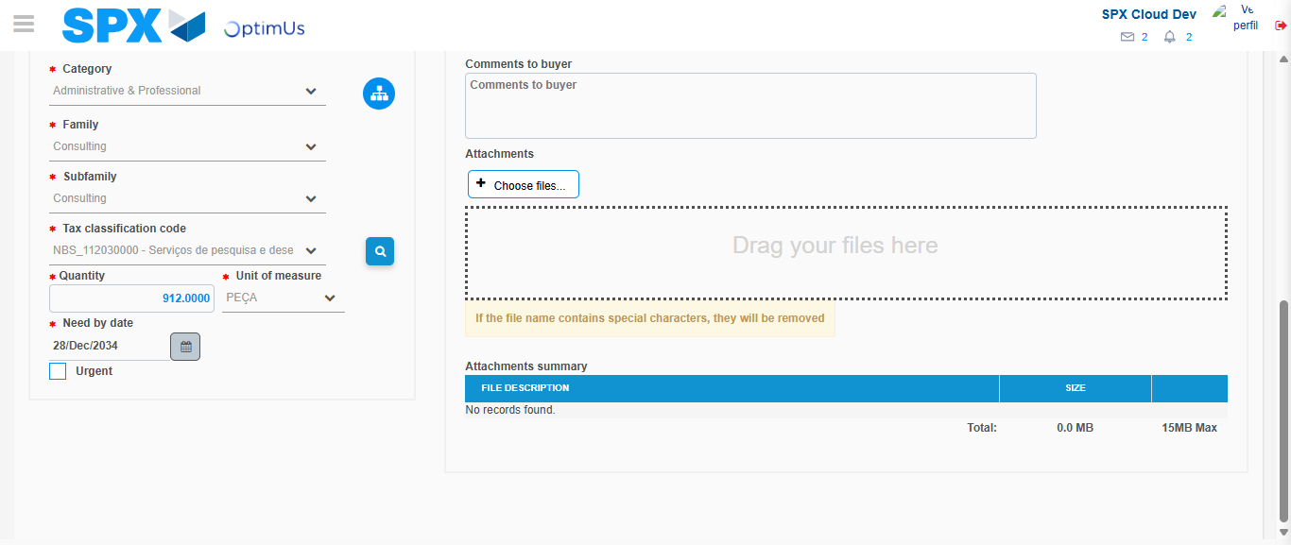Image file-name: QC_Testing-tc001_SPX_Dev5_Crear_Requisicion_Spot_Tipo_Cobro_CC-1788297223413

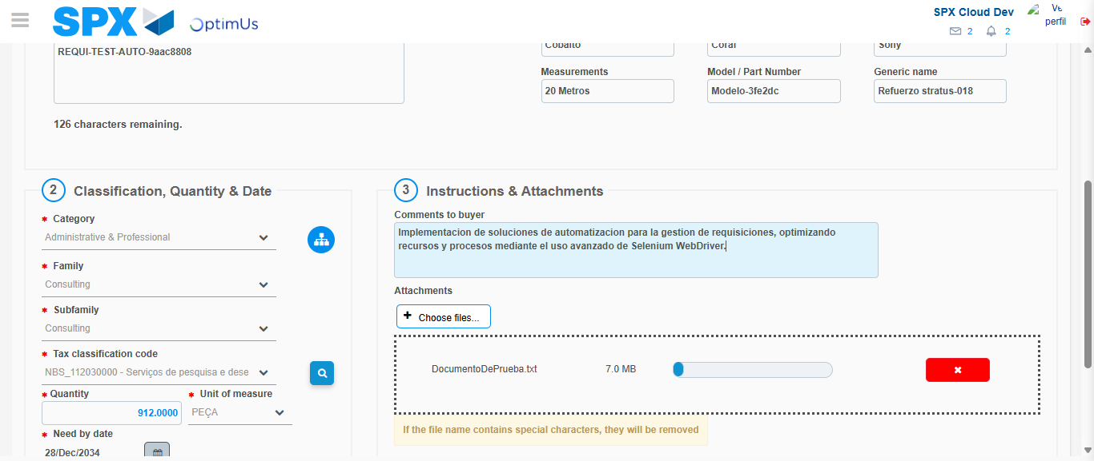Image file-name: QC_Testing-tc001_SPX_Dev5_Crear_Requisicion_Spot_Tipo_Cobro_CC-1788297224158

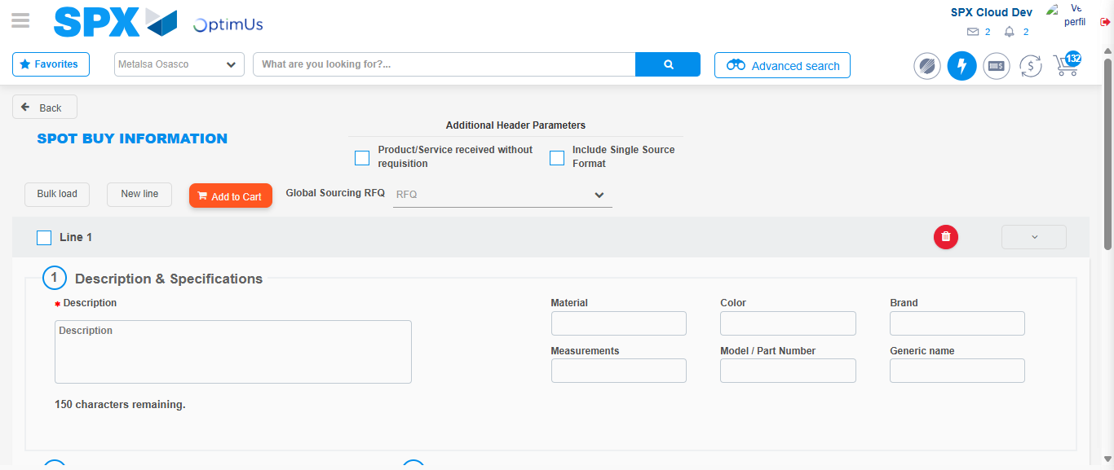Image file-name: QC_Testing-tc001_SPX_Dev5_Crear_Requisicion_Spot_Tipo_Cobro_CC-1788297229149

Step 7 - Return to Main Page SPX : Return to Main Page SPX
Image file-name: QC_Testing-tc001_SPX_Dev5_Crear_Requisicion_Spot_Tipo_Cobro_CC-1788297186868

Image file-name: QC_Testing-tc001_SPX_Dev5_Crear_Requisicion_Spot_Tipo_Cobro_CC-1788297187434

Image file-name: QC_Testing-tc001_SPX_Dev5_Crear_Requisicion_Spot_Tipo_Cobro_CC-1788297210666

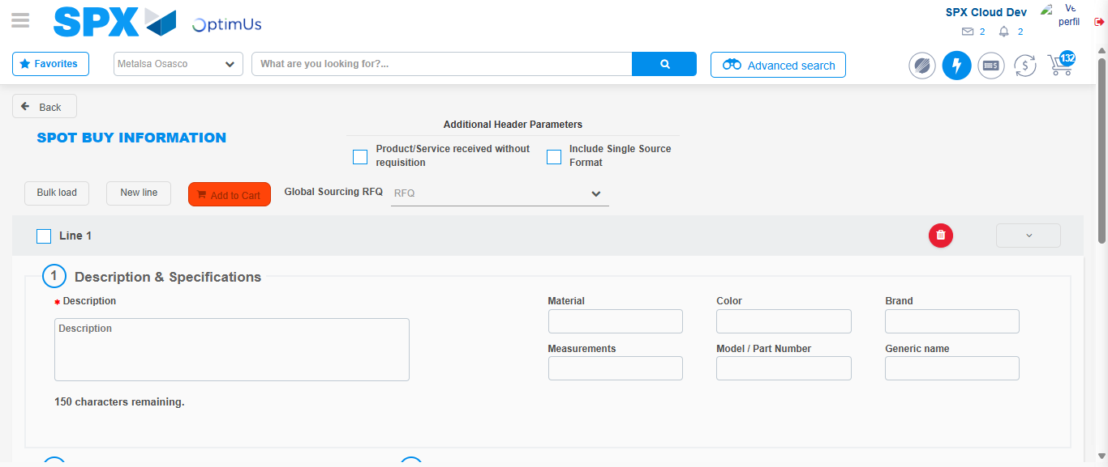Image file-name: QC_Testing-tc001_SPX_Dev5_Crear_Requisicion_Spot_Tipo_Cobro_CC-1788297231357

Image file-name: QC_Testing-tc001_SPX_Dev5_Crear_Requisicion_Spot_Tipo_Cobro_CC-1788297231506

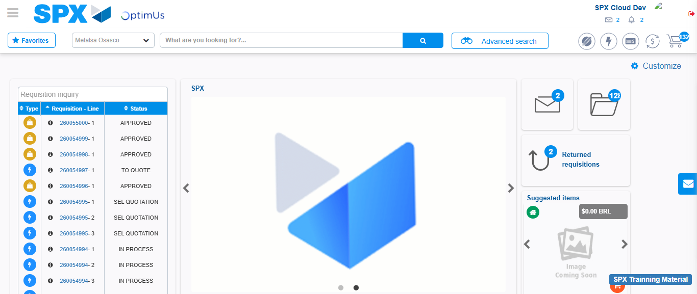Image file-name: QC_Testing-tc001_SPX_Dev5_Crear_Requisicion_Spot_Tipo_Cobro_CC-1788297252489

Step 8 - Log Out : Log Out SPX
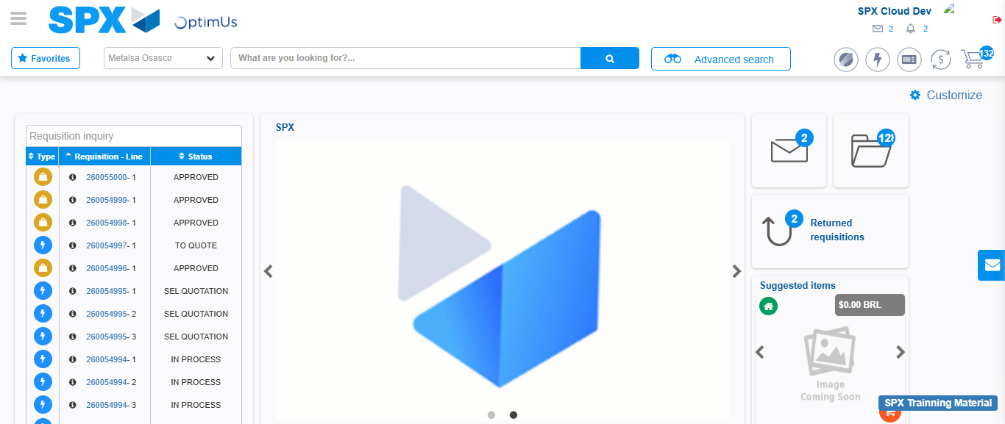Image file-name: QC_Testing-tc001_SPX_Dev5_Crear_Requisicion_Spot_Tipo_Cobro_CC-1788297252779

